
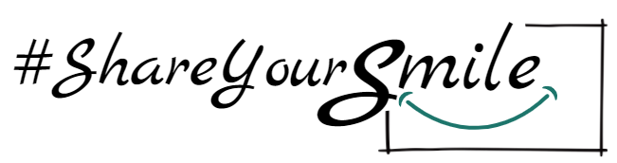
Media Consent Form
Canadian Hard of Hearing Association (CHHA)
Video Marketing Campaign – Show your smile, show your support
Media Consent and Release Form: I hereby irrevocably give the Canadian Hard of Hearing Association (“CHHA”) the right and permission to record my image or likeness while I participate in the Project/Event identified below.
Furthermore, I hereby irrevocably give CHHA the right and permission to use my image or likeness so recorded. CHHA right of use shall include the right to publish, adapt, exhibit, reproduce, edit, distribute, and display my image or likeness in connection with any product or service for any purpose (including, promotion advertising and trade) in all markets, media or technology now known or hereafter developed.
For certainty, and without limiting the above, CHAA right of use shall also allow it to publish my image or likeness on the internet, incorporate my image or likeness into promotional videos and share my image or likeness with media organizations for any purpose.
I shall not have any entitlement to compensation for CHHA recording and use and shall not make any claim against CHAA, its affiliates, agents, event partners, governors, officers and/or employees for damages that may arise from its recording or use including, without limitation, any claim that is based on an alleged misrepresentation, negligence, defamation, breach of privacy, right of publicity infringement or an infringement of any applicable privacy legislation.
By signing my name, I acknowledge that I have read, understand, and agree with the contents contained within this Consent and Release.

Name: ____________________________________________
Phone: ____________________________________________
Email: _____________________________________________
Signature of Participant: __________________________
Date: _____________________________________________

If under 18 years of age, a signature of a parent or guardian is required.
Parent / Guardian: I acknowledge that I have read and understood this Consent and Release. I agree to its terms in connection with the photographic or electronic records of the likeness of my child.
Parent / Guardian Name: ________________________
Signature of Parent/Guardian: ____________________
Date: _______________________________________

